Washington College
Department of Environmental Science and Studies

Modeling Climate Change, Tree Harvest, and Carbon Storage
in a New England Forest with LANDIS-II
Maura Ruthann Collins

A senior thesis submitted to the
Department of Environmental Science and Studies & Department of Math and Computer Science
In partial fulfillment of the requirements for the degree of
Bachelor of Science at Washington College

April 10, 2026
Washington College Honor Code:
I pledge my word of honor that I have abided by the Washington College Honor Code while completing this assignment.

______________________________
Thesis Advisors: Dr. David Kramar & Dr. Dylan Poulsen
______________________________

Abstract
Climate change has altered landscapes by altering precipitation patterns, temperatures, atmospheric carbon dioxide levels, and subsequent growing season length (Anderson-Teixeira et al., 2013; IPCC, 2019). These augmentations can affect the aboveground biomass accrual in temperate forests, which experience timber harvest as the leading cause of mortality (Anderson-Teixeira et al., 2013; Brown et al., 2018). In New England, forests experienced high levels of harvest in the 19th century and are still exhibiting a recovery effect on aboveground biomass accrual as previously cleared pastures are being reforested (Duveneck et al., 2017). While literature suggests the region will continue to serve as a carbon sink, current challenges to recovery threaten it: growing demand for renewable energy, high levels of private land ownership, and high levels of timber harvest (Brown et al., 2018; Canham et al., 2013). In the context of these growing threats, we asked how the interactive effects of climate change and tree harvest could be understood through the forest landscape model, LANDIS-II. We expected that, when modeling the town of Petersham, Massachusetts, climate change would amplify the effects of tree harvesting and reduce carbon storage. These data suggest that over a 100-year period, climate change increases carbon storage in forest land across harvest treatments. This trend aligns with previous studies showing that carbon storage decreases when simulating climate change over longer periods (Duveneck et al., 2017).
Introduction
Climate Change
Over the last two decades, global temperatures have risen 1.53 °C above the pre-industrial levels (IPCC, 2019). This change has been largely driven by a ~46% rise in carbon dioxide levels along with contributions of other greenhouse gases (IPCC, 2019). Rises in carbon dioxide emissions have triggered global climate change. Climate change has numerous effects, altering the start and end of growing seasons, altering precipitation patterns, reducing freshwater availability, and increasing forest ecosystem stress (IPCC, 2019). Emissions can come from a variety of sources, including agriculture and forestry, which are both high-net emitters (IPCC, 2019). Around the world, 22% of all land is used for plantations or managed forestry (IPCC, 2019). Reducing deforestation and increasing afforestation and reforestation have a high technical potential to reduce emissions and remove carbon dioxide (IPCC, 2019). There are large gaps in knowledge about what the best practices for local forestry should look like due to the natural variability of the land (IPCC, 2019).
In addition to being viable climate solutions, forests around the Earth provide numerous economic, ecological, social, and cultural services to people, fostering abundant and diverse biological communities (Bonan, 2008). Covering about one-third of all land, forests regulate hydrological fluxes and thereby support biodiversity and carbon sequestration (Hou et al., 2023). Forest communities store nearly half of all terrestrial carbon (Bonan, 2008). When forests are harvested, the process often releases carbon and interrupts the crucial ecosystem services that trees provide (IPCC, 2019).
Global Tree Harvest
Logging occurs for a variety of reasons: personal use, financial gain, temporary restrictions on logging in other regions, economic rise and downturns, and policy (Brown et al., 2018). There is growing pressure to increase tree harvest to meet renewable energy goals (Brown et al., 2018). Harvest is the leading cause of tree mortality in the northeast United States (Brown et al., 2018; Anderson-Teixeria et al., 2013; Canham et al., 2013). Canham et al (2013) suggest that harvest is the leading cause of adult tree mortality over all other natural and anthropogenic causes combined. Harvest regimes are most frequently partial harvest rather than clear-cut (Brown et al., 2018; Canham et al., 2013). This may be due in part to the fact that clear-cutting is a highly destructive method, similar in effect to wildfires and severe wind events, which can shift the ecosystem back to secondary succession (Odum, 1969).
Harvest in the United States
Across the United States, the intensity of tree harvest in corporate, state, and municipal forests is almost twice that in federal or private woodlands (Thompson et al., 2017). Corporate, state, and municipal forests have a median harvest intensity of about 40% basal area removal during one event. Federal harvest intensity equates to 23% of the median percentage of basal area removed, and private woodland harvest intensities of 20% basal area removed. The annual probability of a harvest event in a public forest is about 1.5%, whereas in a private forest it is 3% (Thompson et al., 2017).
Clear-cutting is a process within the even-aged silvicultural management system that was initially promoted as a regeneration cut, especially effective for upland hardwoods (Roach & Gingrich, 1968). Although not as aesthetic, clear cuts were prized for their high return in timber productivity (Roach & Gingrich, 1968; Smith et al., 1989)
New England
In the United States, New England is a highly forested region. As of 2010, forests account for about 80% of the region’s land cover, with less than 1% being old-growth forest (Thompson et al., 2013). The lack of old-growth forests is due to large-scale timber harvesting in the industrial period. Between the 1820s and 1880s, 80% of the land in New England was open fields, and around 1850, reforestation began due to field abandonment (Foster, 1992). Since these secondary forests are quite young, they are well below their biomass capacity (Thompson et al., 2013). Duveneck et al. (2017) estimate that, even without climate change, New England forests can accumulate about 34% more biomass over the next 100 years, a finding corroborated by Brown et al. (2018). In the context of climate change, forests could accumulate up to 82% more biomass (Duveneck et al., 2017). While many forests around the world may undergo latitudinal migration, forests in New England are unlikely to do so because the trees are well within their southern boundaries (Thompson et al., 2013). This factor allows forests to accumulate higher magnitudes of carbon. Despite the expected increase in carbon, one challenge to this carbon sink is that 80% of the forests in New England are privately owned, meaning that there are fewer regulations on how and when tree harvest occurs.
Climate Change and Tree Harvest
In temperate forests, accelerated biomass accumulation has been observed following disturbances such as harvest (Anderson-Teixeira et al., 2013). Additionally, forests that experience harvest and climate change have exhibited accelerated range contractions or expansions (Wang et al., 2019). Tree harvest affects tree species distributions more than other disturbances because it alters the competition and age structure (Wang et al., 2019). Troublingly, climate change may alter recovery dynamics or prevent recovery, thereby triggering feedback to climate change (Anderson-Teixeira et al., 2013). However, warmer temperatures and greater moisture availability lead to higher rates of biomass accumulation, which sequesters carbon more rapidly (Anderson-Teixeira et al., 2013).
Considering the interactive effects of climate change and tree harvest, we ask: how does tree harvest affect forest carbon storage in New England, and how can LANDIS-II be used to investigate the relationship between forest harvest, carbon storage, and how this may change with climate change? We expect that, by using the simulation model LANDIS-II, we will demonstrate that climate change decreases the amount of carbon stored in aboveground biomass and amplifies the effects of partial harvest.
Methods
Modeling: LANDIS-II
To simulate harvest, we used the Landscape Disturbance and Succession model (LANDIS-II). LANDIS-II simulates spatial ecological processes and patterns, including succession, growth, seed dispersal, harvesting, insect herbivory, and disease (Scheller et al., 2007). LANDIS-II allows the user to parametrize the landscape and life-history traits of tree species present in the landscape, allowing the model to be as specific as desired. Rather than simulating individual trees, trees are aggregated into species-age-cohorts, allowing the model to simulate different generations of succession or the growth of cohorts of specific species. This feature of the model greatly decreases processing time, making it ideal for large landscapes, generally 10⁵ hectares. Smaller-scale simulations have successfully been run, however (Scheller et al., 2007; Reese et al., 2025).

Study Site
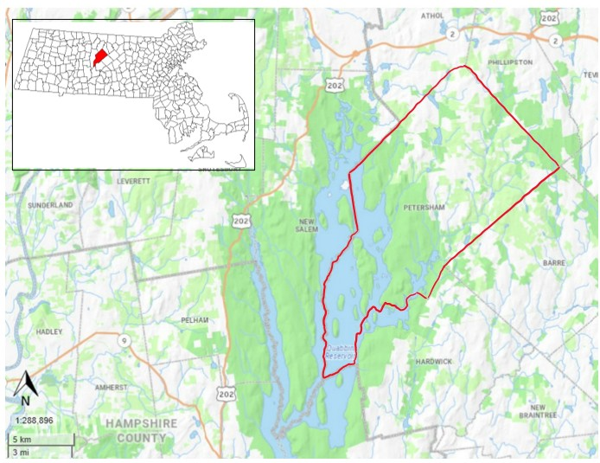
Figure 1. Petersham, Massachusetts, outlined in Red, is bordered by the Quabbin Reservoir to the West and Barre to the East. This township is located at (42.49 N, -72.19 W) and highlighted in Red in the map of Massachusetts to the upper left.
Petersham is a 14,000-ha township located within Worcester County, in the center of Massachusetts. The topography is rolling uplands at 275 m above sea level. The soils are acidic and composed of granodiorite and gneiss (Foster, 1992). There is a 5-month growing season, 105 cm of annual precipitation, and a mean annual temperature of 8.5 C (Foster, 1992). Petersham is 90% forested, with second-growth forest covering about 70% of its Worcester County (Foster, 1992). Dominant tree species include American Hemlock (Tsuga canadensis), Red maple (Acer rubrum), Eastern White Pine (Pinus strobus), and Red Oak (Quercus rubra) (Finzi et al., 2020).
Timber harvest around Petersham is now actively managed by Harvard Forest, which is a rigorously monitored tract of forest (Foster, 1992). Harvard Forest is Harvard University’s field research station. It has hosted decades of research on forest dynamics, notably including the Smithsonian’s Forest Global Earth Observatory network (Anderson-Teixeira et al., 2015) and the National Ecological Observatory Network (NEON, n.d.), most of which provide publicly available data. Timber harvest rates in Harvard Forests from 1990-2014 averaged 0.4% of the forest land per year, removing an average of approximately 590 m³/yr (Finzi et al., 2020). This is a lower frequency of harvesting disturbance than in the surrounding regions (Worcester Plateau and Lower Worcester Plateau ecoregions), where about 1.4% per year was harvested, mostly at low to moderate intensity, during 1984–2015 (McDonald et al., 2006; Thompson et al., 2017).
Experimental Design
We ran two harvest simulations on the 14,000-ha of Petersham, MA. One simulation was run with static climate conditions based on 2004 data, and the other was run with climate change conditions under RCP 8.5. Relative Concentration Pathway (RCP) 8.5 is a climate change projection characterized by increased warm, humid conditions in the New England region and more precipitation events. This scenario represents a ‘business-as-usual’ approach in which greenhouse gases continue to increase and is the most severe climate model version. In tandem with the treatments, we also ran two non-harvest simulations: one with the static climate scenario and one with RCP 8.5 climate change conditions. These two runs serve as control simulations. Each simulation was set to run from 2010 to 2110, after which the aboveground biomass of each forest landscape was compared. Since carbon accounts for roughly 50% of biomass, we estimated carbon storage using aboveground biomass as a proxy.
LANDIS-II Set-up
This simulation is run under LANDIS version 8 (Scheller et al., 2017) at 30 m resolution. The simulation is accompanied by Photosynthesis and Evapotranspiration, PnET-Succession, an extension created by Gustafson et al (2023). The single disturbance extension, Biomass Harvest (version 6), treats Petersham as a single management area and each pixel as an individual stand (Scheller et al., 2024). The prescription was clearcut 40% of the harvest area, following the median basal area removal intensity for a single event in corporate, state, and municipal forests (Thompson et al., 2017). Data for the simulations were collected from Forest Inventory Analysis datasets produced every 10 years by the United States Forest Service. All initial text and spatial file creation, as well as output analysis, were performed in R version 4.2.3 (R Core Team, 2023). For more information on the simulation setup, see the Appendix.
Results
Analysis of the aboveground carbon storage of harvest simulations shows that the RCP8.5 climate change scenario yields 63.81% higher carbon storage than the static climate at the 100-year mark. This trend is repeated between the non-harvest simulations, with a smaller margin, showing that a climate change scenario yields 16.28% higher carbon storage than the static climate (Figure 2). The greatest difference in carbon storage between climate change and static simulation occurs in the No-Harvest simulation at year 80. The margin at this point was 2,554.50 g/m², whereas the average margin between climate change and static, with no harvest, for the entire simulation period was 1,397.00 g/m². The 40% harvest area resulted in an ending difference of 12,136.89 g/m² between the harvest and non-harvest climate change simulations. 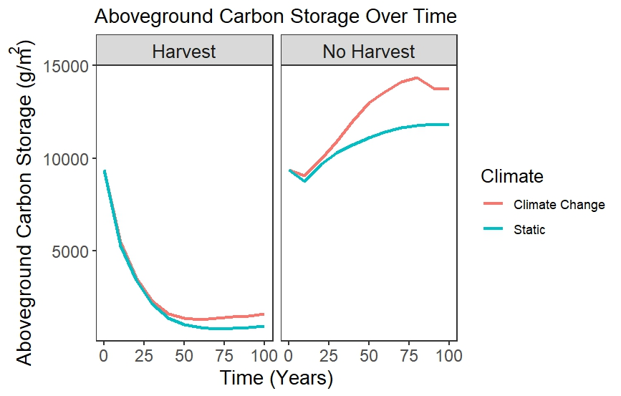
Figure 2. The above-ground carbon storage of the forested area in Petersham is 13% higher in the first 100 years of climate change than in the static climate scenario

Table 1. Carbon storage (g/m²) of four highly abundant species in New England, averaged over a 100-year simulation. Larger differences in mean carbon storage were observed between non-harvest simulations than harvest simulations.
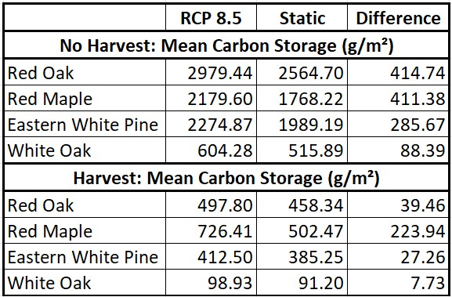
At the species level, carbon storage differences were also large (Table 1). The four species groups with the highest differences in carbon storage were Red Oak, Red Maple, Eastern White Pine, and White Oak for the non-harvest scenarios. Red maple (Acer rubrum) and Eastern White Pine (Pinus strobilus) are Petersham’s most abundant hardwood and softwood species. Consistent with general trends, Red Maple and Eastern White Pine showed higher carbon storage under climate change conditions and lower storage under static climate conditions (Figure 3). The largest difference in carbon storage between the two species occurred in the climate change and harvest simulation. 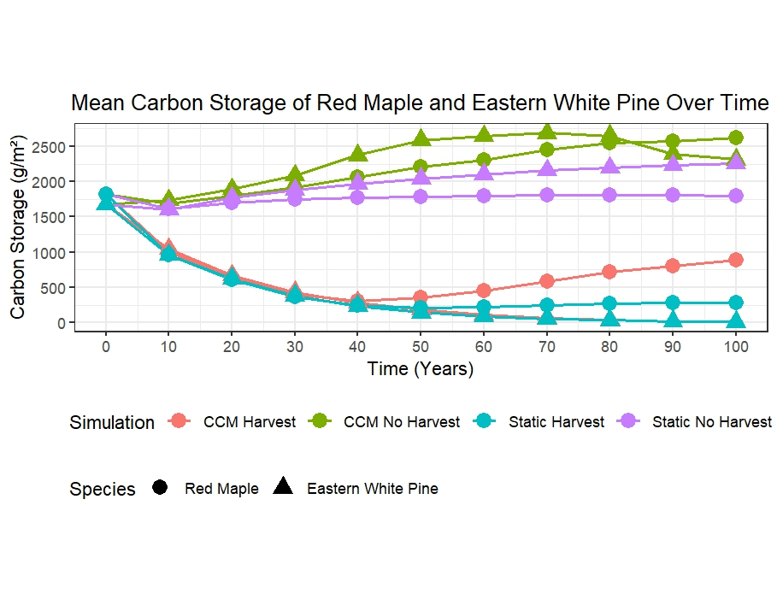Figure 3. Across all four simulations, Eastern White Pine only had higher carbon storage than Red Maple in the simulation with a static climate and no harvest.
Discussion
Based on the results above, we sought to understand how tree harvest affects forest carbon storage in New England and how LANDIS-II can be used to investigate this relationship. These results indicate that within 100 years, climate change will vastly increase the amount of carbon stored in aboveground biomass in Petersham, Massachusetts. This evidence does not support our hypothesis that climate change will result in decreased carbon storage in the forests of Petersham, Massachusetts.
These data indicate clear trends that the RCP 8.5 climate change conditions support higher levels of carbon sequestration, with and without harvest. Previous simulations of New England forests support these results (Duveneck et al., 2017; Finzi et al., 2020; Wang et al., 2017). In a simulation of northeastern US forests, biomass increased from 2000 to 2120, then declined, coinciding with the maximum longevity of the dominant northern hardwood species (Wang et al., 2017). This effect may be explained by the previously discussed widespread timber harvest in the New England region around 1880 (Foster, 1992). Additionally, as a stand's age increases, Yang et al. (2011) observed that the carbon flux rate approaches equilibrium. This study covers only a century of forest growth and therefore does not reflect the possible decline in carbon associated with generational longevity.
Reflecting on the harvest, a 40% area prescription greatly reduces forest carbon storage. This result reflects the cost of high-intensity harvest, demonstrating the strain of clear-cut methodologies as opposed to partial harvest. The frequency may have exaggerated this representation of a clear-cut harvest. Thompson et al. (2017) report that the annual probability of a harvest event in a public forest is 1.5%, which is lower than that in a municipally owned forest (2.4%). Despite the high harvest intensity, this study indicates that climate change will increase forest-level carbon storage over the next 100 years.
These four simulations suggest that the greatest carbon storage may be achieved under climate change conditions with no harvest. In contrast, the least carbon storage would result from a static climate and harvest. Even without climate change, empirical literature predicts that the northeastern region will continue to accumulate carbon storage through succession (Finzi et al., 2020; Thompson et al., 2013; Brown et al., 2018). With an assumed regional increase in carbon storage, the jurisdiction of forest management may play an important role in protecting the carbon sink. Federally managed forests experience a 1% annual probability of harvest, which is the lowest of all classes considered (Thompson et al., 2017).
On a smaller scale, the simulations capture important species-level differences in tolerance for climate change and harvest disturbances. Red Maple, an abundant hardwood species in Massachusetts, displayed the greatest difference in carbon storage between climate scenarios, despite harvest treatments (Table 1). This may suggest that the Red Maple population is particularly sensitive to climate change. In contrast, other hardwoods, like Red and White Oaks, are better suited to withstanding disturbances and climate shifts. Species-level differences in abundance associated with climate change are not supported by the literature (Thompson et al., 2013; Wang et al., 2017). Rather, empirical predictions are that range shifts will not occur within the century for the Petersham area. Thompson et al. (2013) observed simulated increases in biomass for Sugar Maple, which is in the same genus as Red Maple (Acer), suggesting that climate conditions are favorable at the genus level. The most abundant softwood species, Eastern White Pine, displayed greater average carbon storage than Red Maple in the no-harvest static climate scenario (Figure 3). Eastern White Pine, as well as other softwoods, have been noted to be at greater risk to climate change due to range contractions near the year 2300 (Wang et al., 2017). This result is consistent with a situation in which competition is limited, as increased harvest increases competition (Wang et al., 2019).
Limitations
More nuanced differences in species' tolerance to disturbance and climate change may have been analyzed with a longer study period. This simulation was intended to run for 300 years, in alignment with the suggestion of Wang et al. (2017). However, due to constraints in climate estimation, the data cover only 100 years. The literature on New England claims that, despite harvest regimes, carbon storage will increase in this region due to historical overharvesting of forests (Brown et al., 2018). This claim was not supported by this simulation; however, Petersham is a small study area in comparison to the New England region.
Additionally, the raster resolution was set to 30 meters, meaning that the biomass of a 90m² forest area is estimated to be high. This reduces the model's specificity. Since LANDIS is a species-age cohort-level model instead of a tree-level model, a larger resolution may correspond better with the cohort-level estimations (Scheller et al., 2007).
FIA data was imputed into the landscape, meaning that this data might be representative of the forest community that is there, but there is no simple way to know how accurate the estimation is without ground-truthing each tree. Since this would be highly impractical, the model fulfills its purpose of estimating trends over large landscapes without requiring people to check every stem (Scheller et al., 2007). With these limitations taken into consideration, this simulation achieves the broad goals of the study, using modeling to understand the effect of harvest and climate change on carbon storage in forest landscapes.
Conclusions and Implications
Although the results of this study suggest that climate change increases carbon storage across all simulations regardless of harvest, this result is not widely applicable. Simulations by Gustafason et al (2024) indicate that severe climate change under RCP 8.5 reduces carbon storage in high-latitude environments. Harvesting is a useful carbon mitigation strategy when a mature stand is a carbon source (Bellassen & Luyssaert, 2014). As previously discussed, harvest can simulate major disturbance events, which are associated with increased biomass accumulation in temperate forests (Anderson-Teixeira et al., 2013). These considerations should encourage greater site-based decision-making in land management (Bellassen & Luyssaert, 2014; Lucash et al., 2023). Modeling can be a useful tool for informing local decisions, and the potential of these models to predict more complex interactions has increased substantially over time (Shifley et al., 2017). As forest landscape modeling progresses, it is imperative to make these tools available to wider audiences and facilitate better carbon forestry.

References
Anderson-Teixeira, K. J., Miller, A. D., Mohan, J. E., Hudiburg, T. W., Duval, B. D., & DeLucia, E. H. (2013). Altered dynamics of forest recovery under a changing climate. Global Change Biology, 19(7), 2001–2021. https://doi.org/10.1111/gcb.12194
Bechtold, W., & Scott, C. T. (2005). The forest inventory and analysis plot design. Gen. Tech. Rep. SRS-80. Asheville, NC: U.S. Department of Agriculture, Forest Service, Southern Research Station, p. 37-52. https://research.fs.usda.gov/treesearch/20378chec
Bellassen, V., & Luyssaert, S. (2014). Carbon sequestration: Managing forests in uncertain times. Nature, 506(7487), 153–155. https://doi.org/10.1038/506153a
Box, G. E. P., & Draper, N. R. (1987). Empirical model-building and response surfaces (pp. xiv, 669). John Wiley & Sons.
Brown, M. L., Canham, C. D., Murphy, L., & Donovan, T. M. (2018). Timber harvest as the predominant disturbance regime in northeastern U.S. forests: Effects of harvest intensification. Ecosphere, 9(3), e02062. https://doi.org/10.1002/ecs2.2062
Canham, C. D., Rogers, N., & Buchholz, T. (2013). Regional variation in forest harvest regimes in the northeastern United States. Ecological Applications, 23(3), 515–522. https://doi.org/10.1890/12-0180.1
Duveneck, M. J., Thompson, J. R., Gustafson, E. J., Liang, Y., & De Bruijn, A. M. G. (2017). Recovery dynamics and climate change effects to future New England forests. Landscape Ecology, 32(7), 1385–1397. https://doi.org/10.1007/s10980-016-0415-5
Finzi, A. C., Giasson, M.A., Barker Plotkin, A. A., Aber, J. D., Boose, E. R., Davidson, E. A., Dietze, M. C., Ellison, A. M., Frey, S. D., Goldman, E., Keenan, T. F., Melillo, J. M., Munger, J. W., Nadelhoffer, K. J., Ollinger, S. V., Orwig, D. A., Pederson, N., Richardson, A. D., Savage, K., … Foster, D. R. (2020). Carbon budget of the Harvard Forest Long-Term Ecological Research site: Pattern, process, and response to global change. Ecological Monographs, 90(4), e01423. https://doi.org/10.1002/ecm.1423
Foster, D. R. (1992). Land-Use History (1730-1990) and Vegetation Dynamics in Central New England, USA. Journal of Ecology, 80(4), 753–771. https://doi.org/10.2307/2260864
Gustafson, E. J., Miranda, B. R., Sturtevant, B.R., Zhou, Z. (2023). PnET-Succession v 5.1: Comprehensive description of an ecophysiological succession extension within the LANDIS-II forest landscape model. The LANDIS-II Foundation. https://github.com/LANDIS-II-Foundation/FoundationPublications/blob/main/Description%20of%20PnET-Succession%20v5.1.pdf
Gustafson, E. J., Lucash, M. S., Shvidenko, A., Sturtevant, B. R., Schepaschenko, D., Mast, C., & Williams, N. (2024). Climate Change Threatens the Sustainability of Current Timber Harvesting Practices Across a Latitudinal Gradient in Siberia. SSRN. https://doi.org/10.2139/ssrn.4887075
Hou, Y., Wei, X., Zhang, M., Creed, I. F., McNulty, S. G., & Ferraz, S. F. B. (2023). A global synthesis of hydrological sensitivities to deforestation and forestation. Forest Ecology and Management, 529, 120718. https://doi.org/10.1016/j.foreco.2022.120718
Jenkins, J. C., Chojnacky, D. C., Heath, L. S., & Birdsey, R. A. (2003). National-Scale Biomass Estimators for United States Tree Species. Forest Science, 49(1), 12–35. https://doi.org/10.1093/forestscience/49.1.12
Lucash, M. S., Williams, N. G., Srikrishnan, V., Keller, K., Scheller, R. M., Hegelson, C., Nicholas, R. E., & Smithwick, E. A. H. (2023). Balancing multiple forest management objectives under climate change in central Wisconsin, U.S.A. Trees, Forests and People, 14, 100460. https://doi.org/10.1016/j.tfp.2023.100460
McDonald, R. I., Motzkin, G., Bank, M. S., Kittredge, D. B., Burk, J., & Foster, D. R. (2006). Forest harvesting and land-use conversion over two decades in Massachusetts. Forest Ecology and Management, 227(1–2), 31–41. https://doi.org/10.1016/j.foreco.2006.02.006
Odum, E. P. (1969). The Strategy of Ecosystem Development. Science, 164(3877), 262–270.
Overview | NSF NEON | Open Data to Understand our Ecosystems. (n.d.). Retrieved April 10, 2026, from https://www.neonscience.org/about/overview
Raster Definition | GIS Dictionary. (n.d.). Retrieved April 10, 2026, from https://support.esri.com/en-us/gis-dictionary/raster
Reese, G. C., Sturtevant, B. R., Dymond, C. C., Quigley, K. M., Duveneck, M. J., Lucash, M. S., Gustafson, E. J., Scheller, R. M., Russell, M. B., & Miranda, B. R. (2025). Best practices for calibration of forest landscape models using fine-scaled reference information. Canadian Journal of Forest Research, 55, 1–19. https://doi.org/10.1139/cjfr-2024-0085
Roach, B. A., & Gingrich, S. F. (1968). Even-aged Silviculture for Upland Central Hardwoods. U.S. Forest Service.
Scheller, R. M., Domingo, J. B., Sturtevant, B. R., Williams, J. S., Rudy, A., Gustafson, E. J., & Mladenoff, D. J. (2007). Design, development, and application of LANDIS-II, a spatial landscape simulation model with flexible temporal and spatial resolution. Ecological Modeling, 201(3–4), 409–419. https://doi.org/10.1016/j.ecolmodel.2006.10.009
Scheller, R., Sturtevant, B. R., Gustafson, E. J., Miranda, B. R., Zollner, P. A., Mladenoff, D. J., & Domingo, J. B. (2024, June 24). Harvest v 6.0 LANDIS-II Extension User Guide. The LANDIS Foundation. https://github.com/LANDIS-II-Foundation/Extension-Biomass-Harvest
Shifley, S. R., He, H. S., Lischke, H., Wang, W. J., Jin, W., Gustafson, E. J., Thompson, J. R., Thompson, F. R., Dijak, W. D., & Yang, J. (2017). The past and future of modeling forest dynamics: From growth and yield curves to forest landscape models. Landscape Ecology, 32(7), 1307–1325. https://doi.org/10.1007/s10980-017-0540-9
Smith, H. C., Lamson, N. I., & Miller, G. W. (1989). An Esthetic Alternative to Clearcutting? Journal of Forestry, 87(3), 14–18. https://doi.org/10.1093/jof/87.3.14
Vashum, K. T., & Jayakumar, S. (2012). Methods to Estimate Above-Ground Biomass and Carbon Stock in Natural Forests—A Review. Journal of Ecosystem & Ecography, 02(04). https://doi.org/10.4172/2157-7625.1000116
R Core Team. (2023). R A language and environment for statistical computing (4.2.3) [Computer software]. R Foundation for Statistical Computing.
Thompson, J. R., Canham, C. D., Morreale, L., Kittredge, D. B., & Butler, B. (2017). Social and biophysical variation in regional timber harvest regimes. Ecological Applications, 27(3), 942–955. https://doi.org/10.1002/eap.1497
Thompson, J. R., Carpenter, D. N., Cogbill, C. V., & Foster, D. R. (2013). Four Centuries of Change in Northeastern United States Forests. PLoS ONE, 8(9), e72540. https://doi.org/10.1371/journal.pone.0072540
Vissage, J. S., Greer, T. R., & Brandeis, T. J. (2019). Site class and site index: Two estimates of site quality for the Southern Research Station Forest Inventory and Analysis Program (SRS-RN-25; p. SRS-RN-25). U.S. Department of Agriculture, Forest Service, Southern Research Station. https://doi.org/10.2737/SRS-RN-25
Wang, W. J., He, H. S., Thompson, F. R., Fraser, J. S., & Dijak, W. D. (2017). Changes in forest biomass and tree species distribution under climate change in the northeastern United States. Landscape Ecology, 32(7), 1399–1413. https://doi.org/10.1007/s10980-016-0429-z
Wang, W. J., Thompson III, F. R., He, H. S., Fraser, J. S., Dijak, W. D., & Jones-Farrand, T. (2019). Climate change and tree harvest interact to affect future changes in tree species distribution. Journal of Ecology, 107(4), 1901–1917. https://doi.org/10.1111/1365-2745.13144
Yang, Y., Luo, Y., & Finzi, A. C. (2011). Carbon and nitrogen dynamics during forest stand development: A global synthesis. New Phytologist, 190(4), 977–989. https://doi.org/10.1111/j.1469-8137.2011.03645.x

Appendix
Overview
We simulated a 14,000-ha area, Petersham, with version 8 of the LANDIS-II model, hereafter referred to as LANDIS. The Landscape Disturbance and Succession (LANDIS-II) model simulates spatial ecological processes and patterns, including succession, growth, seed dispersal, harvesting, insect herbivory, and disease (Scheller et al., 2007).
LANDIS-II allows the user to parametrize the landscape and life-history traits of tree species present on the landscape, allowing the model to be as specific as desired (Scheller et al., 2007). To decrease processing time, individual trees are binned into species-age-cohorts such that the model can simulate different generations of succession or growth of cohorts rather than individual stems (Scheller et al., 2007).
Model Inputs
LANDIS depends on two core inputs, Ecoregion and Initial Communities (Scheller et al., 2007). These are supported by two other rasters, which are vital to the succession extension: Leaf Litter and Coarse Woody Debris. A raster is a data structure that is used with geographic data (Raster Definition, n.d). Rasters are matrices composed of pixels or cells, which can be organized as bands (Raster Definition, n.d). Bands can contain information on landscape characteristics, for example: elevation, tree species, temperature, leaf litter abundance, etc. (Raster Definition, n.d.). All rasters are 30-meter resolution, meaning that each cell represents a 30x30m area of land, and Harvard Forest’s Thompson Lab server hosted the data and code for these rasters. All model input files were created in R with scripts written by Danelle LaFlower. These scripts were modified for this study. Additional modifications to the LANDIS setup files were made in C#. Each simulation was run with a set seed to ensure consistency between batches.
Initial Communities Files
The Initial Communities raster contains information on the geographic locations of species cohorts within the study area. The raster works in tandem with an Initial Communities text file, which lists the species, age cohort, biomass, and the associated cell for each cohort. Several different species-age cohorts can exist in the same cell. The species are signaled with a ‘genuspec’ code, where the first four letters of the code are the genus of the tree, and the second four letters are the species of the tree. For instance, Red Maple (Acer rubrum) becomes acerrubr. The species in this Initial Communities file and raster were determined using USFS Forest Inventory and Analysis (FIA) data from the New England Region, pulled on March 16th, 2026. FIA plots capture a variety of attributes from a subset of trees within a plot, which users can employ to estimate ages and species composition of stands in their own plots (Bechtold & Scott, 2005). This method can create gaps; however, the plots in the Petersham area were matched with FIA plots using an imputed raster and an accompanying crosswalk developed by Dr. Xiaojie Gao, a postdoctoral researcher at Harvard Forest. When simulation is performed in a censused area, species-age cohorts may be entered based on ground-truth data. Data imputation becomes necessary in large landscapes where it is logistically inefficient or impossible to access all forest stands (Scheller et al., 2007).
In this study, tree age is estimated using height, site index, and species-specific allometric equations (Finzi et al., 2020; Jenkins et al., 2003). Vissage et al. (2019) define site index as a metric of ecosystem productivity, determined by the average total height that dominant and codominant trees in a stand will attain at a specific age. Allometric equations represent established relationships between physical characteristics (See Figure 4) (Vashum & Jayakumar, 2012). Once age is calculated, the user determines the cohort's age groupings. For this simulation, we chose 0, 25, 50, 75, 100, 125, and 175 as the age cohorts that would best represent the age stratification of the forest in Harvard Forest, Petersham, MA [unpublished work from 2025 summer internship].
The biomass of trees in the simulation is determined from the FIA aboveground biomass estimates of individual trees in pounds, which are halved to estimate carbon, and then converted to grams per square meter. Once the age and biomass are determined, the biomass is summed by species-age cohort.
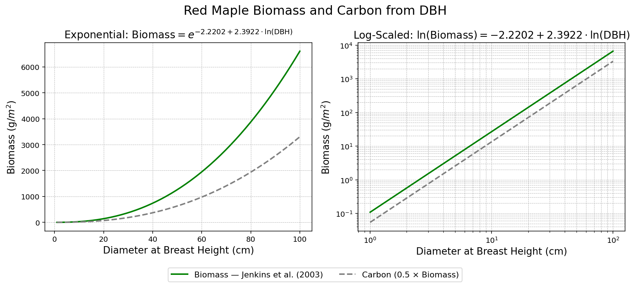
Figure 4. Above-ground biomass (g/m²) can be modeled using the relationship between biomass and DBH for Red Maple (Acer rubrum). Jenkins et al. (2003) determined the coefficients used as inputs to allometric growth models by transforming the equation representing the observed relationship (left) into a linear form (right). Once the relationship is log-scale, the coefficients are the slope and the intercept. This logarithmic transformation is written below:
$$Biomass = e^{-2.2202+2.3922×ln\left(DBH\right)} = 0.1086{\left(DBH\right)}^{2.3922}$$
$$ln(Biomass) = -2.2202 + 2.3922×ln(DBH)$$
Ecoregion
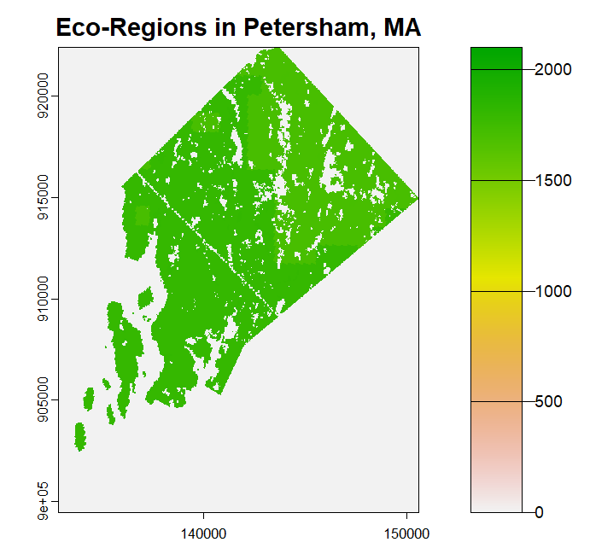
The ecoregion raster and files contain a range of region-level environmental conditions, including soil type, rooting depth, snow sublimation, and a reference to an ecoregion-specific climate file. The climate files available on the server outline environmental conditions at 10-year timesteps for 200 years in an RCP8.5 simulation and a 2004 static climate simulation. The climactic variables in these files are the maximum and minimum temperature (Celsius), the photosynthetic active radiation (PAR), precipitation levels (mm), carbon dioxide (ppm), and ozone levels for every month of the years 1950-2099, and with general range estimates of these environmental variables from 1299-1949 and 2100-2200. This simulation contained 9 ecoregions, and the raster was clipped and resampled from a previously created ecoregion raster of Massachusetts.

Figure 5. The Ecoregion raster contains nine ecoregions, and the inactive cells are represented as zeroes so that they are not simulated. Ecoregions correspond with specific sets of climate variable predictions, meaning that each region calls a separate climate simulation file.
Leaf Litter and Coarse Woody Debris
Litter and Coarse Woody Debris rasters estimate the carbon stored in each reservoir and are derived from FIA data. Like the previous rasters, these are cell-specific values.

Extensions
In addition to the main four rasters, LANDIS depends on files specific to succession extension, a disturbance extension, and an output extension. As stated in the main body section, we used PnET-Succession, extension (Gustafson et al., 2023). This extension is also the output extension and operated at 1-year time-steps starting from the year 2010. This extension calls for the above rasters and accompanying text files.
The only disturbance extension used was Biomass Harvest (version 6), which ran on a 10-year time step (Scheller et al., 2024). This extension references two additional rasters: a stand raster and a management area raster. For this experiment, each stand was defined as a pixel, so each pixel in the stand raster received a corresponding cell count. The entire study area was treated as a single management area, so each pixel received the value ‘1’. The only prescription set for this simulation was to clearcut 40% of the harvest area.
Model Output
The main variable of interest in this simulation was aboveground biomass, which was output at 10-year timesteps by species and summed across the entire study area. To utilize the species-cohort modeling feature, information on species-specific carbon storage was also of interest. All data analysis and visualization were performed in R.
Modeling Reflection
The intention of this thesis was to challenge myself to use the LANDIS background I gained from a summer internship with Harvard Forest, working with species-age-cohort size, and use the model for a different purpose. Harvest simulation is a relatively common practice in landscape ecology as well as other disciplines, and fulfills the human-environment interaction aspect of the project that I needed for the Environmental Science thesis. Throughout my undergraduate experience, I have always gravitated towards forests, so forest modeling seemed like a good subject to focus on to express what I am interested in as a human being and aspiring scientist, as well as what I have learned as a student of both Data Science and Environmental Science.
Along the path of this project, I was particularly challenged by navigating code written by other collaborators due to the sheer number of variables put into play with LANDIS. I experienced a non-insignificant learning curve to understanding a different workflow, new jargon, and abbreviations, as well as how the fundamental model assumptions used to estimate the values, tree biomass, and tree age models were also built on allometries and compound metrics. In school, much of the data and code we work with is labeled to a level that students can understand. I was incredibly fortunate to have a responsive and knowledgeable mentor, Danelle Laflower, who worked with me through my moments of confusion and stress.
Facing the challenge of setting up files for the Biomass Harvest extension was a gratifying process. I initially had planned on utilizing the Base Harvest extension, but that version of the extension was not available for LANDIS 8, so I ended up pivoting. Choosing this task pushed me to build my problem-solving skills and teach myself how to navigate highly technical documentation. The choices I made to keep the harvest simulation parameters as simple as possible allowed me to explore how well the harvesting extension worked with the succession extension.
In the end, I was unable to run the simulation for as long as I had initially planned, which made my hypothesis seem slightly misguided. My original thought process was that even though literature showed climate change would increase the carbon storage in a 100-year period, there would eventually be a trade-off point where the extreme heat and climate shifts, as well as the harvest, would cause a decrease in carbon storage. Unfortunately, since the model did not run for the planned 300-year period, I was unable to test my true original hypothesis. This is not necessarily a limitation.
As I have been reminded by everyone who routinely works with models, ‘all model are wrong, but some are useful’, an aphorism originally expressed by the statistician George Box (Box & Draper, 1987). Extrapolating beyond 100 years from 2010 would mean the model's error would only increase, reducing its representativeness. I am satisfied with what I have learned from this project, and I feel as though it challenged and pushed me to be a better Environmental and Data Science student, and so I want to thank my advisors, Dr. Poulsen and Dr. Kramar.

